Computation Physics
Phys 6312

Project of

The Structure of White dwarf stars

Done By:
Mohammed K. El-habbash
120080242

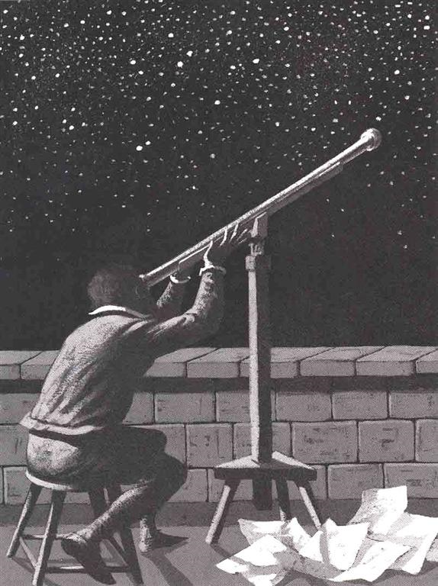

Supervisor:
Dr. Maher O. El-Ghossain
Associate Professor

Contents:

1. Abstract
2. Introduction
3. Theory
3.1 Equation of equilibrium
3.2 The equation of state of the white dwarf
3.3 Dimensionless form of the differential equations
4. Programming
4.1 Programming techniques
4.2 Code of main program and functions
4.3 Code of Functions:
4.4 Code of testing the behavior of alpha(x):
4.5 Code of testing the behavior of gamma(x):
5. Results
5.1 Result of testing the behavior of Alpha(x)
5.2 Result of testing the behavior of Gamma(x)
5.3 Result of ( 12C ►► Ye=0.5)
5.3 Result of ( 56Fe ►► Ye=0.5)
6. Conclusion
1. Abstract:
This project is designed and built to study astronomy phenomena called white dwarf stars , which is a great and important phenomena in the astronomy science.
My project here aimed to analysis data that comes from telescopes and sensors, and then we can expect much information about the universe, such as the structure of white dwarf stars.
In the introduction I give some general information about white dwarf stars, and some principles that related to the phenomena such as : degeneracy pressure, categories of white dwarf stars , the difference between white dwarf and neutron stars, the difference between white dwarf and black dwarf stars, and the equilibrium state of the white dwarf stars.
In the theory chapter I analysis the problem mathematically, I deduce the Equation of equilibrium, then the equation of state of the white dwarf , After that we can reach the dimensionless form of the differential equations , which is called also the Scaling the differential equation.
In programming chapter I clarify the techniques that I used in my program . also I found that it is suites for me to use Matlab program which is famous mathematical analysis program. Also I write down the code and functions that I used in my program.
In the next chapter I put some sampling result that I picked up, to show evidence of my work and mathematical analysis.
In the final chapter, there is some brief conclusion about the work and project in general.

2. Introduction:
After a mid-sized star ejects its outer layers as a planetary nebula and runs out of fuel, what remains is a blazing-hot mass of carbon and densely-packed electrons called a “white dwarf”. Some 97% of all stars, including the Sun, will end their lives as a white dwarf. These are dim objects, but a few are bright enough for you to see with a telescope.
White dwarfs represent the endpoint of stellar evolution for stars with initial masses between approximately 0.07 msun and 8-10 msun, where msun is the mass of the Sun (more massive stars end their life as either black holes or neutron stars).
The theory of stellar evolution predicts that the majority of white dwarfs have a core made of carbon and oxygen, which itself is surrounded by a helium layer. All white dwarfs therefore have been traditionally found to belong to one of two categories:
1- Those with a hydrogen-rich atmosphere (the DA spectral type)
2- and those with a helium-rich atmosphere (the non-DAs).
A white dwarf is essentially a stellar cinder; it produces no heat of its own, but radiates away residual heat from the star’s core over many billions of years. White dwarfs have a temperature of 5,000-40,000 degrees, but they have a low surface brightness. A white dwarf is essentially a stellar cinder; it produces no heat of its own, but radiates away residual heat from the star’s core over many billions of years. White dwarfs have a temperature of 5,000-40,000 degrees, but they have a low surface brightness. Typical white dwarfs have a mass near that of the Sun, but a radius of the Earth. So a white dwarf is very dense: 1 cubic centimeter has a mass of 1,000 kg!
A thin skin of gaseous hydrogen or helium surrounds each white dwarf. Light passing through this hot gas allows astronomers to figure out the temperature, composition, and even the magnetic field strength of a white dwarf. The electrons in a white dwarf are stripped from the carbon atoms and tightly squeezed together. When this happens, they exhibit a strange quantum-mechanical effect called “degeneracy pressure” that holds the star up against the crushing pull of its own gravity. But there’s a limit to how much the electron pressure can withstand. If the mass of the white dwarf exceeds about 1.4x the mass of our Sun, the star will continue to collapse further into an even stranger body called a “neutron star”. This upper mass limit is called the “Chandrasekhar Limit” after the brilliant Indian physicist who discovered it when he was only 21 years old. Eventually, every white dwarf will radiate away its residual energy and become a “black dwarf”. This takes billions of years, however, and the universe is not yet old enough to contain any black dwarf stars.
Good example of white dwarf is: "Sirius", the “Dog Star”, has a companion star called Sirius B. Also known as the “Pup”, Sirius B is the brightest white dwarf in the sky. The Pup was first spotted by Alvan Clark in 1862.
In general white dwarf stars are famous end of nuclear process that occurs in stars. White dwarf stars are cold objects made up of heavy nuclei such as 56Fe, with 26 protons, 30 neutrons and their respective electrons. But if the nuclei synthesis terminates prematurely, 12C nuclei might predominate.
The structure of White dwarf stars is determined by the balance between gravitational forces, which act to compress the star, and electron degeneracy pressure, which act to resist the compression.
The structure of White dwarf stars can be determined by solving this equation of balance.
Charge equilibrium results in an equal quantity of electrons and protons. These stars are the endpoints of stars with masses of the size or smaller than our sun. They are the outcome of standard nuclear processes and end their lives as cold objects like white dwarfs when they have used up all their nuclear fuel.

3. Theory:

3.1 Equation of equilibrium:

Assuming that the star has a spherical shape , so the state of matter at any point in the star depends only on the distance to the center of the star.
We also assume that the star in not rotating and the effect of magnetic field is not important.
Consider an element of the star in mechanical equilibrium, i.e. the gravitational force acting on the element of volume is balanced by the pressure interior to it.

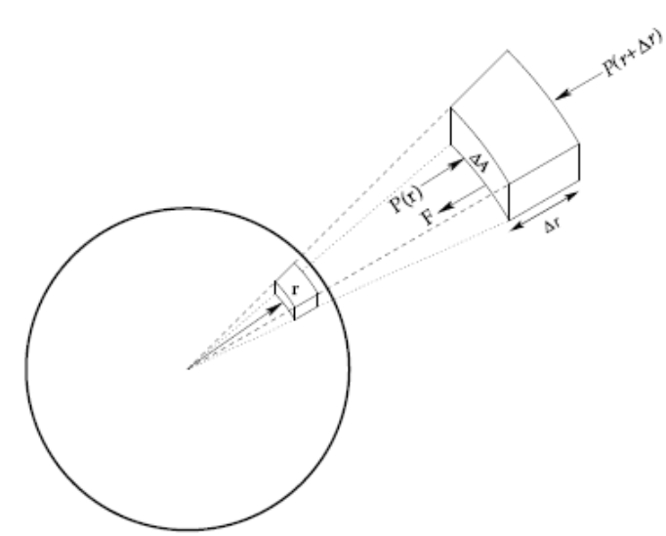

If the area of element is dA , and its uniform density is then the mass of this element is d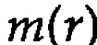 = 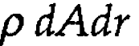, and the total mass of star is , where :

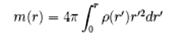

Which can be written as a differential equation:

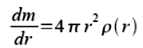

The weight of one element of volume is:

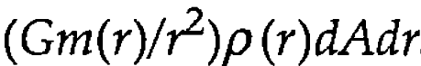

where G is the gravitational constant, and the gravitational force per unit volume of matter at a distance r from the center of star can be defined by:

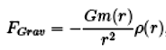

The pressure P(r) is grater than the pressure P(r+dr) by just the weight per unit area of material between r and dr.
Now we can write the hydrostatic equilibrium equation as:

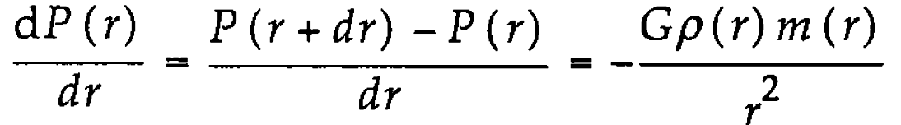

Where G is the gravitational constant , m(r) is the mass of the star interior to r , and the minus sign (-) indicate the pressure increases as r decreases.
Writing density as a function of radius using the relation:

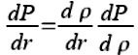

Rewriting hydrostatic equilibrium equation:

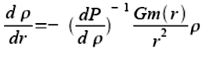

Now we have two differential equations:

With boundary condition at r =0 are:

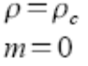

In order to solve the differential equations, we must find pressure (P) as a function of mass density (p), also known as the equation of state of the white dwarf.

3.2 The equation of state of the white dwarf:

When the temperature of the star is low enough, the electrons fill the lowest possible quantum levels. Since the nuclei are very heavy compared to the electrons, we can assume that most of the mass of the star comes from the nuclei.
The electrons are moving much faster than the nuclei, so most of the pressure comes from the electrons.
The density in the star is so high that the electrons are not bound to individual nuclei, but rather move freely about the star. Therefore, a good model for the white dwarf star is a free Fermi gas of relativistic electrons at zero temperature.
In the free Fermi gas, all electrons occupy the lowest energy state with momentum p ≤ pf.

Where pf =³√(3π²n) : is Fermi momentum.

Each of these states are 2-fold degenerate with 2 electrons in each cell of volume h³
Now number density of electrons is:

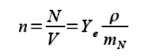

Where:
n(p)= number of electron per unit volume as a function of momentum p.
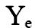= electrons per nucleon
= nucleon mass

Note: Ye =0.5 for 12C
Ye=0.464 for 56Fe

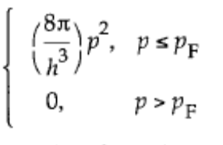
There are two spin states per level

n(p)=

And the total number of electrons per unit volume n=N/V is:

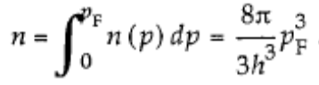

The total energy density of N number of electrons is:

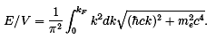

Put c = ħ = 1 , then we have :
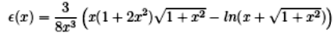
Where:

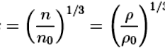
Put x =( pf /me)

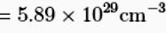
no =(me)³/(3π²) ; me : electron mass.

Now using thermodynamics relation:

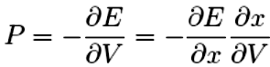

From this equation  we can find that:

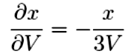

Now we can say that:

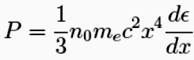

Now find derivative of pressure (P) in terms of the mass density (p).

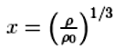
Remember that:

Now calculate:

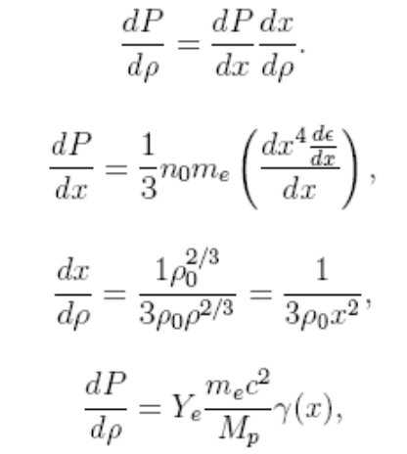

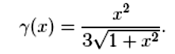
Where:

Now we can deal with previous two differential equations :

With boundary condition at r =0 are:

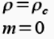

3.3 Dimensionless form of the differential equations (Scaling the differential equation):

In the numerical treatment of the two differential equations we need to rescale our equations in terms of dimensionless quantities, since several of the involved constants are either extremely large or very small.
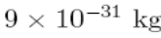
Furthermore, the total mass is of the order of the mass of the sun, approximately 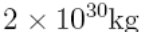 while the mass of the electron
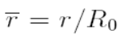
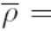
We introduce therefore a dimensionless radius , a dimensionless mass density and a dimensionless mass 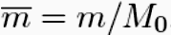.
Then we get:
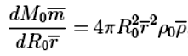

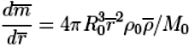

If we want this equation to be dimensionless, we must require:
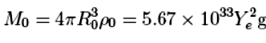
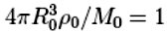
►►

And we get :
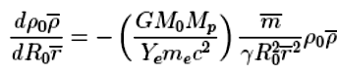

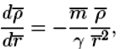
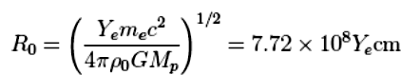
And thus the dimensionless differential equations are:

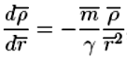

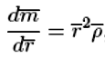

To give some feeling for the scales , recall that the solar radius and mass are:

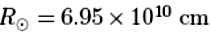
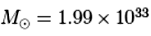

4. Programming

4.1 Programming techniques:

I use Matlab for programming my project, because it easy and have already built function to solve differential equations.
I used ode32.m function, which is member of odexx.m functions, and here are the descriptions of this family:

Solver | Problem Type | Order of Accuracy | When to Use
ode45 | Non stiff | Medium | Most of the time. This should be the first solver you try.
ode23 | stiff | Low | For problems with crude error tolerances or for solving moderately stiff problems.
ode113 | Non stiff | Low to high | For problems with stringent error tolerances or for solving computationally intensive problems.
ode15s | Stiff | Low to medium | If ode45 is slow because the problem is stiff.
ode23s | Stiff | Low | If using crude error tolerances to solve stiff systems and the mass matrix is constant.
ode23t | Moderately Stiff | Low | For moderately stiff problems if you need a solution without numerical damping.
ode23tb | Stiff | Low | i f using crude error tolerances to solve stiff systems.
An example of non stiff system:
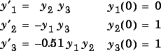

An example of stiff system:
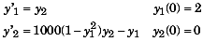
For our system here:

It is clear that it is stiff system, so it is suited to use:
[ode23, ode15, ode23s, ode23t, ode23tb].

Solver solve systems of equations in the form or problems that involve a mass matrix,
The ode23s solver can solve only equations with constant mass matrices. ode15s and ode23t can solve problems with a mass matrix that is singular, i.e., differential-algebraic equations (DAEs).

I prefer to use ode23 function because it professional and astronomy need such function to avoid big errors.
I divide my program into subroutines (functions), and a main program:

Program | Description
Whitedwarf.m | main program
diff1.m | our differential equation
Alpha1.m | Function : to calculate
Gamma1.m | Function : to calculate
x.m | Function : to calculate

4.2 Code of main program and functions:

%====================================================================
% Whitedwarf.m
%====================================================================

% 'whitedwarf.m', integrates the dimensionless
% differential equations for white dwarf structure and internal and
% gravitational energies.
% These equations are in file 'diff1.m'.

% In 'diff1.m', 'set' is the 4 column vectors:
% set(1)='d(rhobar)/d(rbar)',
% set(2)= 'd(mbar)/d(rbar)',
% set(3)=d(ubar)/d(rbar),
% set(4)=d(dblubar)/d(rbar).
% ubar is the scaled internal energy, and Wbar is the scaled
% gravitational energy.

%'sol' (solution) is the 4 column vectors:
% sol(:,1)=rhobar;
% sol(:,2)=mbar;
% sol(:,3)=ubar;
% sol(:,4)=Wbar;

% The subroutine 'ode23' integrates from "rstart" to "rend".
% and using the command "find" we determine the radius of the
% star by choosing the max "rbar" where "rhobar" is non-zero
% or negative.

% then rbar, rhobar, mbar, ubar and dblubar are rescaled to
% obtain, if desired, the values in solar units.
%====================================================================

% Initialising.
sol=[]
rhobar=[];
mbar=[];
rbar=[];
ubar=[];
dblubar=[];

%====================================================================
% Central density.
disp('The dimensionless central density must be specified.')
disp('A value of 1 corresponds to about a 0.5 solar mass star')
disp('for Ye=electrons/nucleus=0.5.')

rhocbar=input('Input dimensionless central density of white dwarf [1] >> ');
if isempty(rhocbar) % default value
rhocbar=1;
end

disp('Calculation started. Please wait ...')
%====================================================================

Ye=0.5; % The number of electrons per nucleons.
% Ye=0.5 12C
% Ye=0.464 56Fe
%================ Normalising constants for radius, mass, density====
%========================= and the two energies.=====================
G=6.67*10^(-8);
R0=7.72*10^8*Ye;
M0=5.67*10^(33)*Ye^2;
rho0=9.79*10^5*Ye^(-1);
dblu0=(G*M0*M0)/(R0);
u0=dblu0;

%********************************************************************
%============= This is to avoid the singularity in the centre,rbar=0.
%=========== Initial value for mass, mstart, at a region close to the
%=========== centre, rstart. We then determine mrstart from the =====
%============= equations below. =====================================

%============= The initial energies at the centre are================
%============= both zero.===========================================

rstart=10^(-10);
mrstart=(1/3)*rhocbar*(rstart^3);
rhostart=rhocbar-(rhocbar*rhocbar*rstart*rstart)/( 6*Gamma1( x(rhocbar) ) );
ubarstart=0;
dblubarstart=0;

%********************************************************************

rendlarge=5; % The outer limit of integration.

sol0=[ rhostart mrstart ubarstart dblubarstart]; % Initial conditions
% for the "trial"
% integration.

%######################## Begin "trial" integration. ###############

[allrbar,sol]=ode23(@diff1,[rstart rendlarge],sol0,[1e-6 1e-6 1e-6]);
figure;
plot(allrbar,sol(:,1),'black');
grid;
xlabel('rbar')
ylabel('rhobar')

figure;
plot(allrbar,sol(:,2),'black');
grid;
xlabel('rbar')
ylabel('mbar')
figure;
plot(allrbar,sol(:,3),'black');
grid;
xlabel('rbar')
ylabel('Ubar')

figure;
plot(allrbar,sol(:,4),'black');
grid;
xlabel('rbar')
ylabel('Wbar')

plot(allrbar,sol(:,1),'black-',allrbar,sol(:,2),'black-.',allrbar,sol(:,3),'black*',allrbar,sol(:,4),'black.')
legend('rhobar: -', 'mbar: -.' , 'Ubar: -*','Wbar :..');
xlabel('rbar')
%ylabel('Y (meter)')

4.3 Code of Functions:

diff1.m
% diff1.m contains the DE's called by whitedwarf.m.
% =====================================
function set=diff1(rbar,sol)
set(1)= - sol(2)*sol(1)/(Gamma1(x(sol(1)))*rbar^2 (;
set(2)=rbar^2*sol(1);
set(3)=alpha( x(sol(1)) )*rbar^2;
set(4)=-sol(2)*sol(1)*rbar;
%******************End of diff1.m***************

Alpha.m
function a=Alpha(x)
a=3/(8*x^3)*( x*(1+2*x^2)*sqrt(1+x^2)-log10( x+sqrt(1+x^2))) ;

Gamma1.m

% Gamma1.m is called by whitedwarf.m
% ===================================
function G=Gamma1(x);
G=x^2/( 3*sqrt(1+x^2));
% ************ End of Gamma1.m ************

x.m

% x.m is called by either whitedwarf.m
%===================================
function ex=x(rhobar)
ex=rhobar^(1/3)
%*************** End of x.m**************
4.4 Code of testing the behavior of alpha(x):

Test1.m

% this program is to determine the leading behaviour of alpha(x)

% for x>>1
x=1:0.1:200;
i=1:1:size(x');
y=alpha1(x');
figure;
plot(x,y,'black--');
legend('x>>1');
xlabel('x')
ylabel('alpha(x)')

% for x<<1
x=1:-0.02:0;
i=1:1:size(x');
y=alpha1(x');
figure;
plot(x,y,'black--');
legend('x>>1');
xlabel('x')
ylabel('alpha(x)')
4.5 Code of testing the behavior of gamma(x):

Test2.m

% this program is to determine the leading behaviour of gamma(x)

% for x>>1
x=1:0.1:200;
i=1:1:size(x');
y=Gamma1(x');
figure;
plot(x,y,'black--');
legend('x>>1');
xlabel('x')
ylabel('Gamma(x)')

% for x<<1
x=1:-0.02:0;
i=1:1:size(x');
y=Gamma1(x');
figure;
plot(x,y,'black--');
legend('x>>1');
xlabel('x')
ylabel('Gamma(x)')

5. Results:

5.1 Result of testing the behavior of Alpha(x):

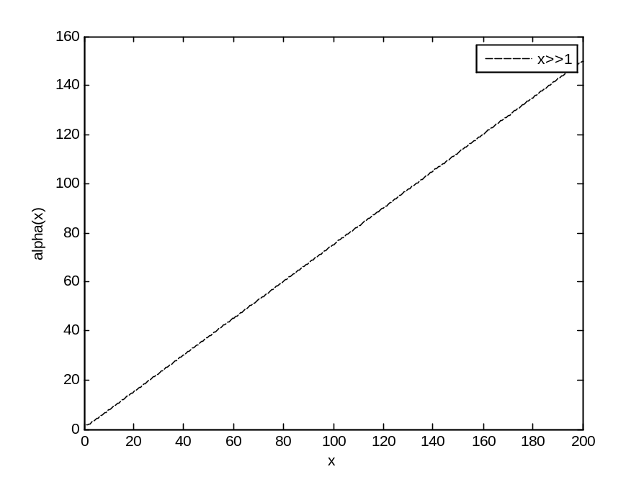

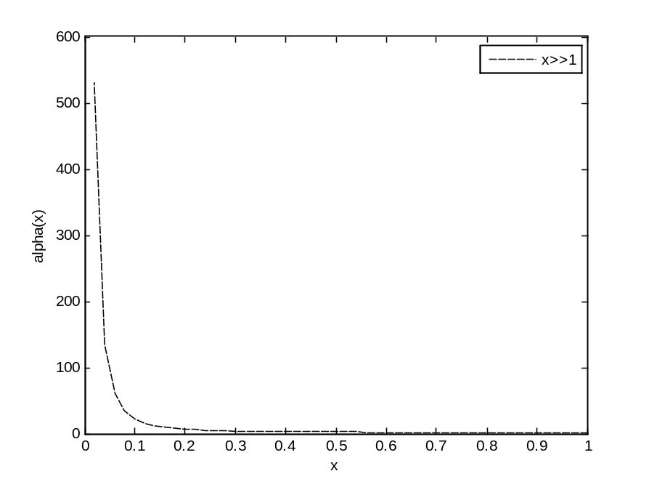

5.2 Result of testing the behavior of Gamma(x):

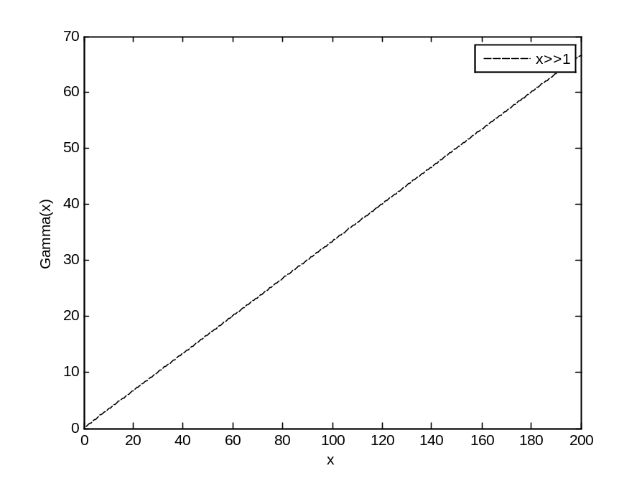

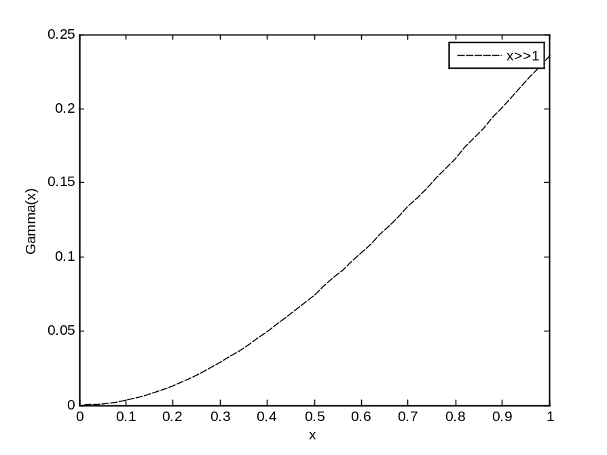
5.3 Result of ( 12C ►► Ye=0.5):
(a) Density changing according to estimated radii.
(b) Mass changing according to estimated radii.
(c) Total Kinetic and rest energy changing according to estimated radii.
(d) Total Gravitational energy changing according to estimated radii.

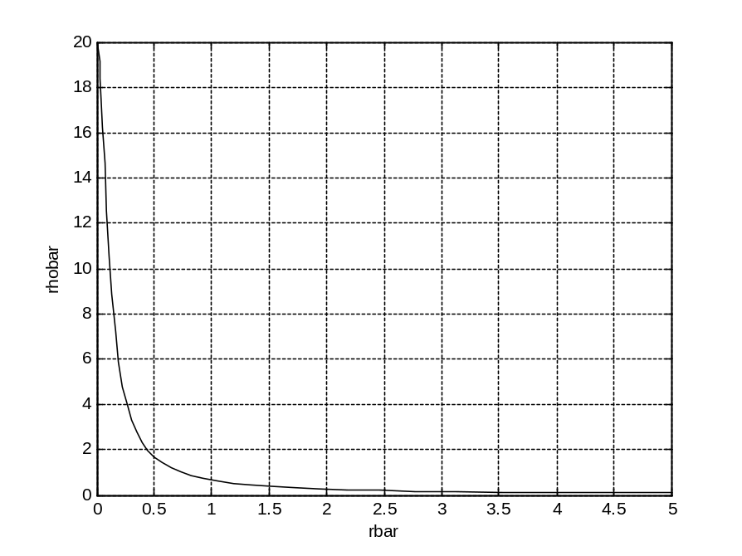

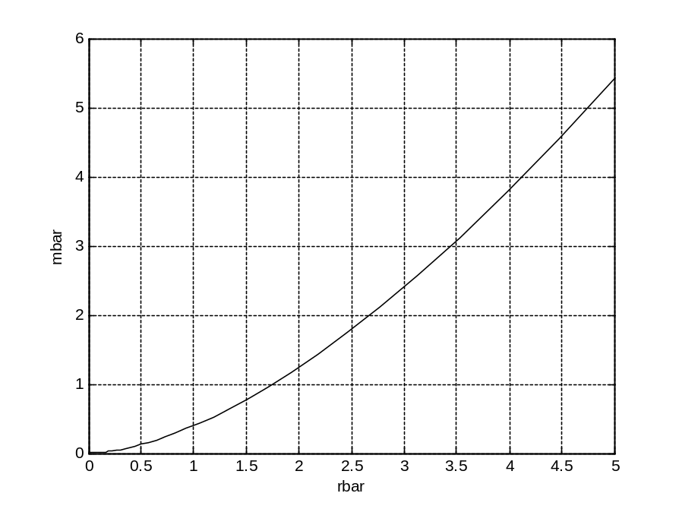
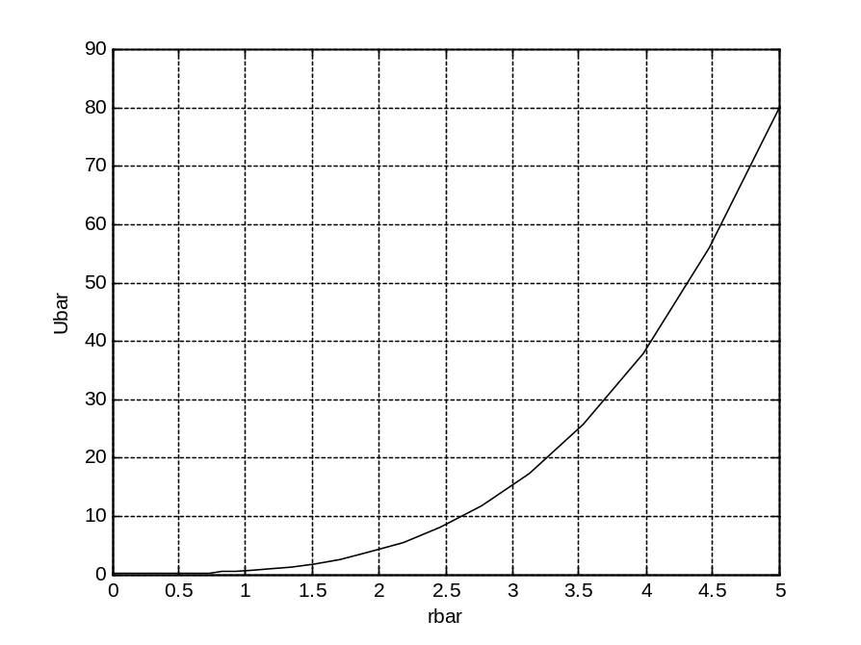

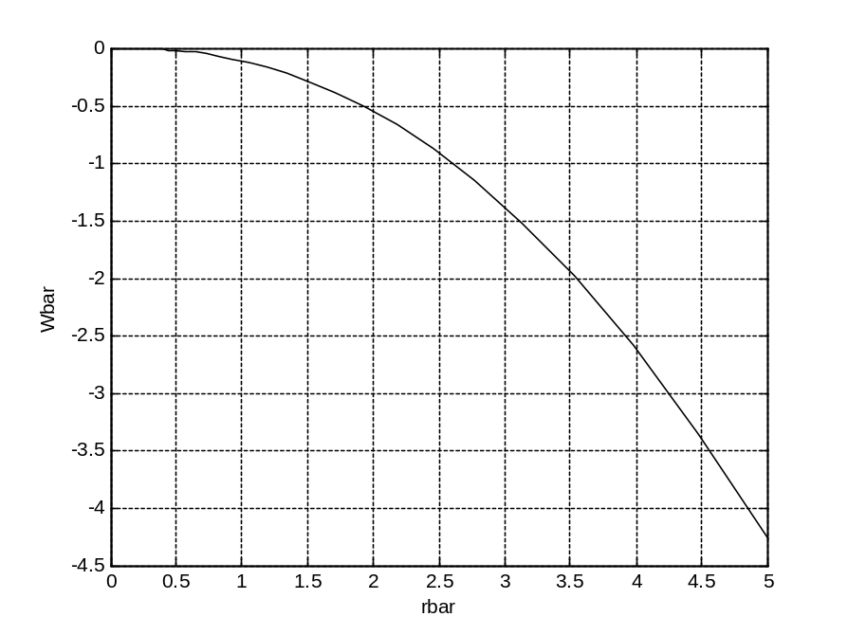

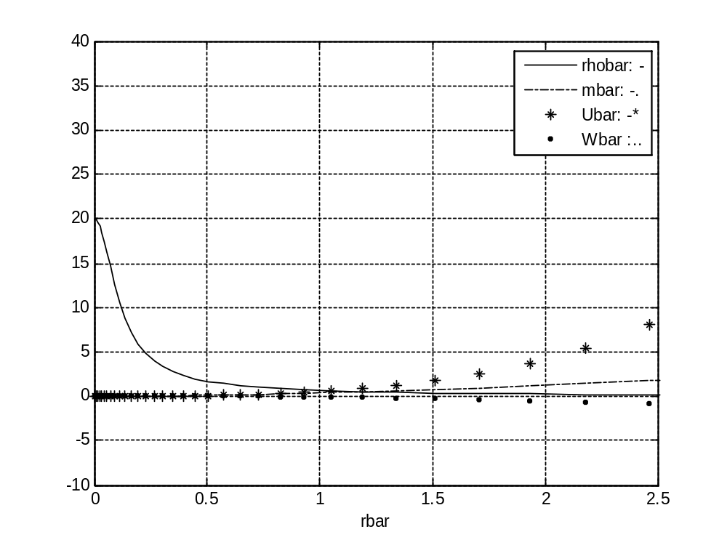
5.3 Result of ( 56Fe ►► Ye=0.5):
(a) Density changing according to estimated radii.
(b) Mass changing according to estimated radii.
(c) Total Kinetic and rest energy changing according to estimated radii.
(d) Total Gravitational energy changing according to estimated radii.

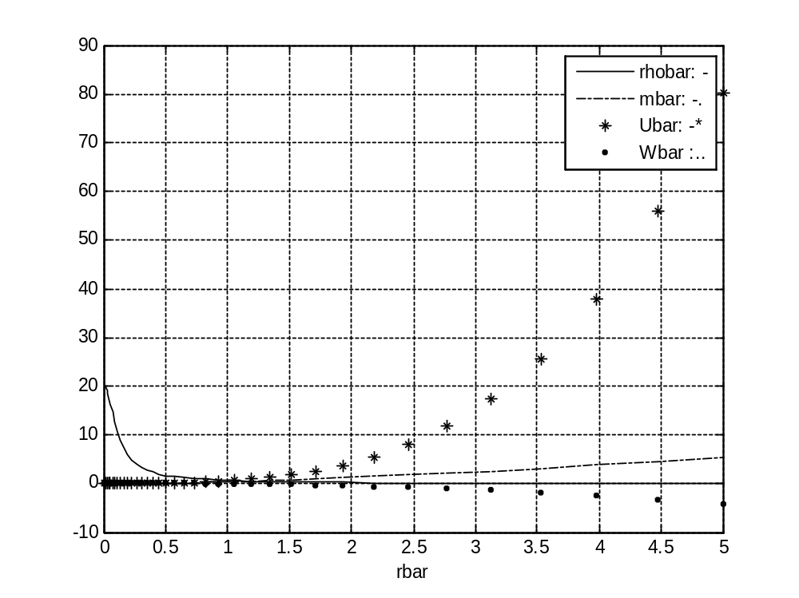
6. Conclusion:

From result one can find that:

Mass density increases when radius decreases.
Mass density decreases when radius increases.

Mass per unit volume increases when radius increases
Mass per unit volume decreases when radius decreases

Total Kinetic and rest energy of electrons increases when radius increases
Total Kinetic and rest energy of electrons decreases when radius decreases

Total Gravitational energy increases when radius decreases
Total Gravitational energy decreases when radius increases.

